

Appendix Contents:

1. UK Road Network Use page 3
2. Chocolate Ratings page 9
3. My own research - Sleep Analysis page 12

**UK Road Network Use Full Code -** Screen Shots from the corresponding Jupyter Notebook file

Chocolate Rating Analysis

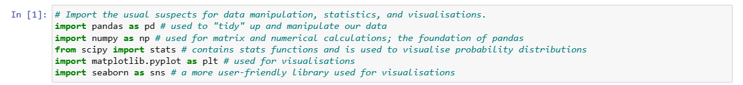

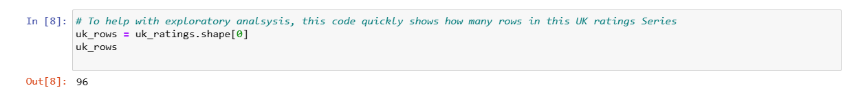

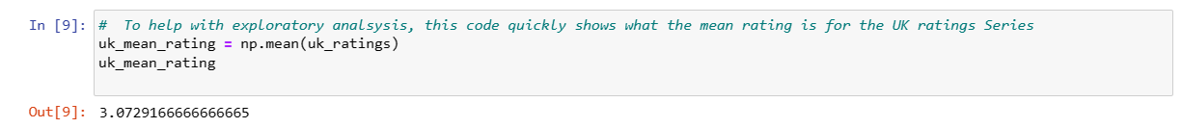

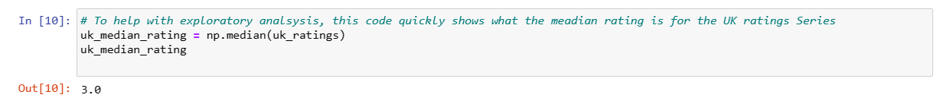

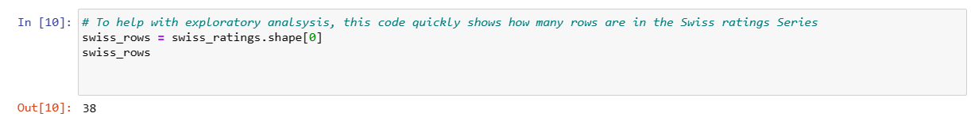

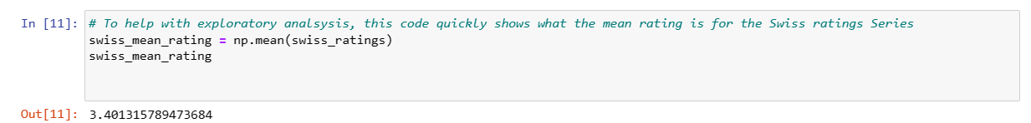

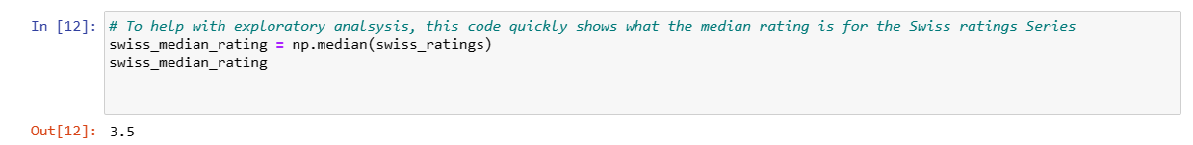

My Own Research – Sleep Analysis

(NB the dataset was small, so the results are not statistically significant)



